**Excellence by Design**



Facility Rail Study: Achieving Target Production



TRUCK MANUFACTURER

Project Description

A major truck manufacturer based in Mexico contracted Design Systems, Inc. (DSI) to evaluate and optimize its plant wide rail delivery network due to the increase in production capacity. DSI utilized various engineering techniques and resources to analyze the current delivery model and identify process bottlenecks constraining the elevated production targets. The team was also expected to recommend process and facility requirements to achieve the target production.



PROJECT OUTCOMES

* Identified bottlenecks based on the information collected from the plant.
* Evaluated congestion in the network using Factory flow software to assess the requirement of additional infrastructure.
* Recommended operational improvements to support the target production rate with current infrastructure thereby saving capital.
* Generated future infrastructure concepts and recommendations to further improve the responsiveness of the network.
* Project outcome -



MANUFACTURING

Client Objectives

* Establish the current state parameters.
* Evaluate the critical points in the process like wagon capacity, non-value added time in yard operations, replenishment times, intermodal yard capacity etc.
* Generate recommendations based on attainability, impact on machine, requirements, costs, and expected benefits

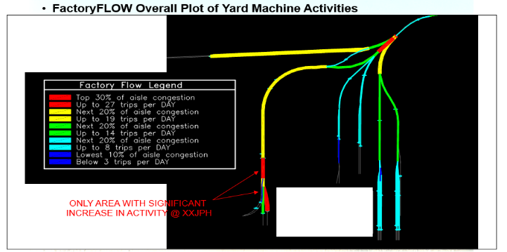

FactoryFLOW Overall Plot of Yard Machine Activities

ONLY AREA WITH SIGNIFICANT INCREASE IN ACTIVITY



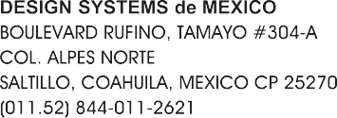

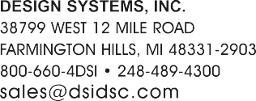

4657

